**Assignment 3**

1.

select Departments.DEPT_NAME as Department,sum(Salary) as Salary from Employees,Departments where Employees.DID=Departments.DEPT_ID

group by Departments.DEPT_NAME;

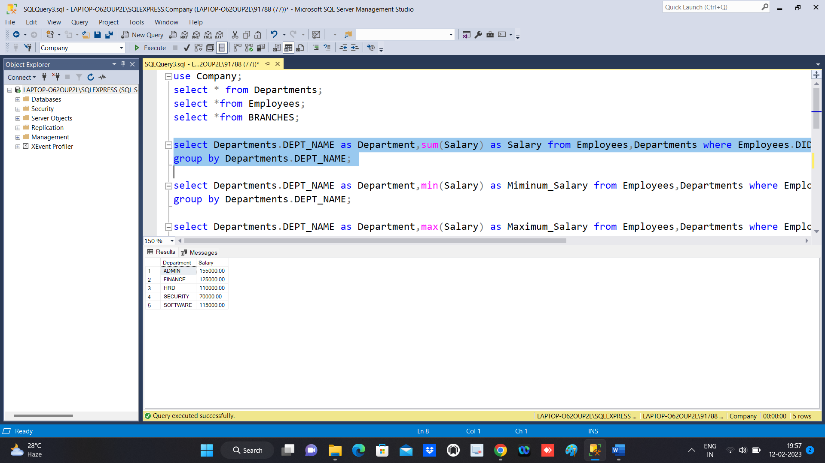

2.

**2.1**

select Departments.DEPT_NAME as Department,min(Salary) as Miminum_Salary from Employees,Departments where Employees.DID=Departments.DEPT_ID

group by Departments.DEPT_NAME;

**2.2**

select Departments.DEPT_NAME as Department,max(Salary) as Maximum_Salary from Employees,Departments where Employees.DID=Departments.DEPT_ID

group by Departments.DEPT_NAME;

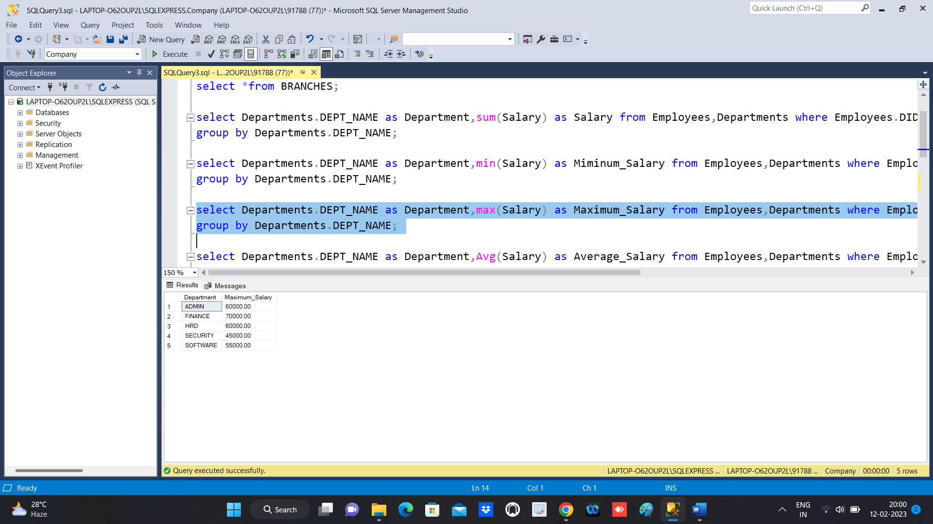

**2.3**

select Departments.DEPT_NAME as Department,Avg(Salary) as Average_Salary from Employees,Departments where Employees.DID=Departments.DEPT_ID

group by Departments.DEPT_NAME;

**3.**

select Departments.DEPT_NAME as Department ,Count(Departments.DEPT_ID) as Total_Emp from Employees,Departments where Employees.DID=Departments.DEPT_ID

group by Departments.DEPT_NAME;

**4.**

select BRANCHES.BRACH_NAME as Branch,Departments.DEPT_NAME as Department, Sum(Employees.Salary) as Total_Salary

from Employees,Departments,BRANCHES where Employees.DID=Departments.DEPT_ID and BRANCHES.BID=Employees.DID

group by Departments.DEPT_NAME,BRANCHES.BRACH_NAME;

